
Program :B.tech(CSE)
Specialization :AIML
Course Title :AI Assisted Coding
Course Code :24CS002PC215
Semester :3rd semester
Academic Session :2025-2026
Name of Student :Bachanagari Deekshitha
Enrollment No. :2403A52032
Batch No. :02
Date :04/11/2025
#LAB ASSIGNMENT-15.3
#TASK DESCRIPTION-1:
Basic REST API Setup
Task: Ask AI to generate a Flask REST API with one route:
GET /hello → returns {"message": "Hello, AI Coding!"}
#PROMPT:
Generate a complete and executable Python Flask REST API with one route:
GET /hello → returns JSON response {"message": "Hello, AI Coding!"}.
Include all necessary imports, Flask app creation, and the if __name__ == "__main__": block to run the server.
Keep the code short, clean, and fully runnable.
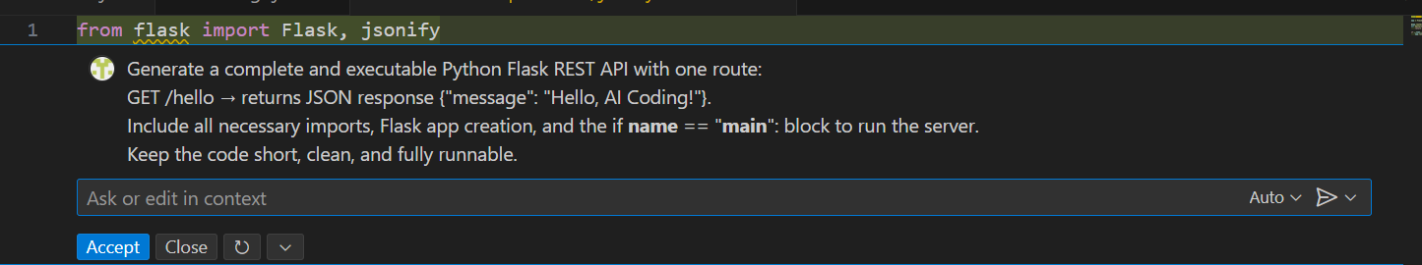
#CODE:
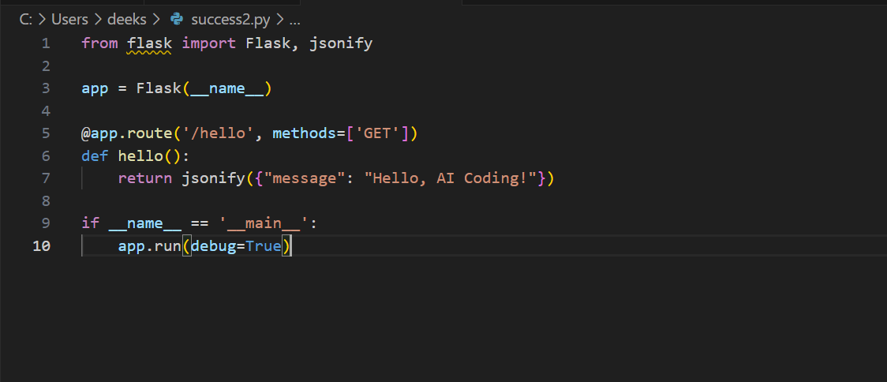
# OUTPUT:
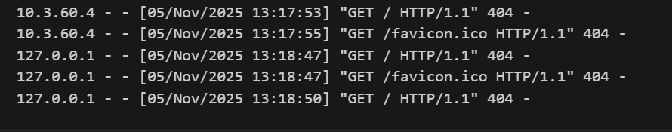
#TASK DESCRIPTION-2:
CRUD Operations (Students API)
Task:
Use AI to build REST endpoints for a Student API:
• GET /students → List all students.
• POST /students → Add a new student.
• PUT /students/<id> → Update student details.
• DELETE /students/<id> → Delete a student.
#PROMPT:
Generate a complete and executable Node.js + Express REST API for managing students with the following endpoints:
• GET /students → Return a list of all students.
• POST /students → Add a new student (with fields: id, name, age, course).
• PUT /students/:id → Update a student’s details by ID.
• DELETE /students/:id → Delete a student by ID.
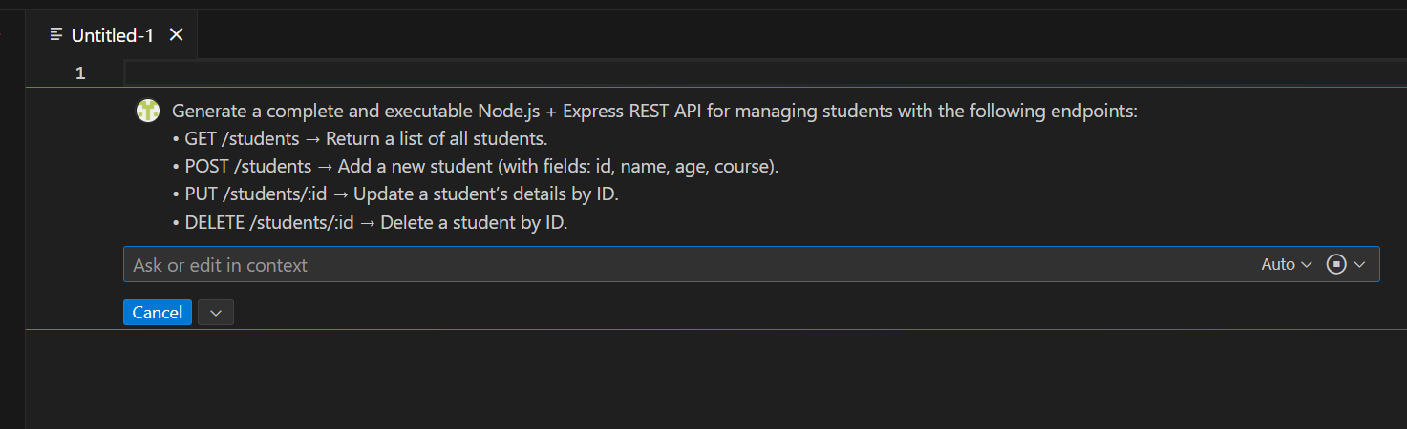
#CODE:
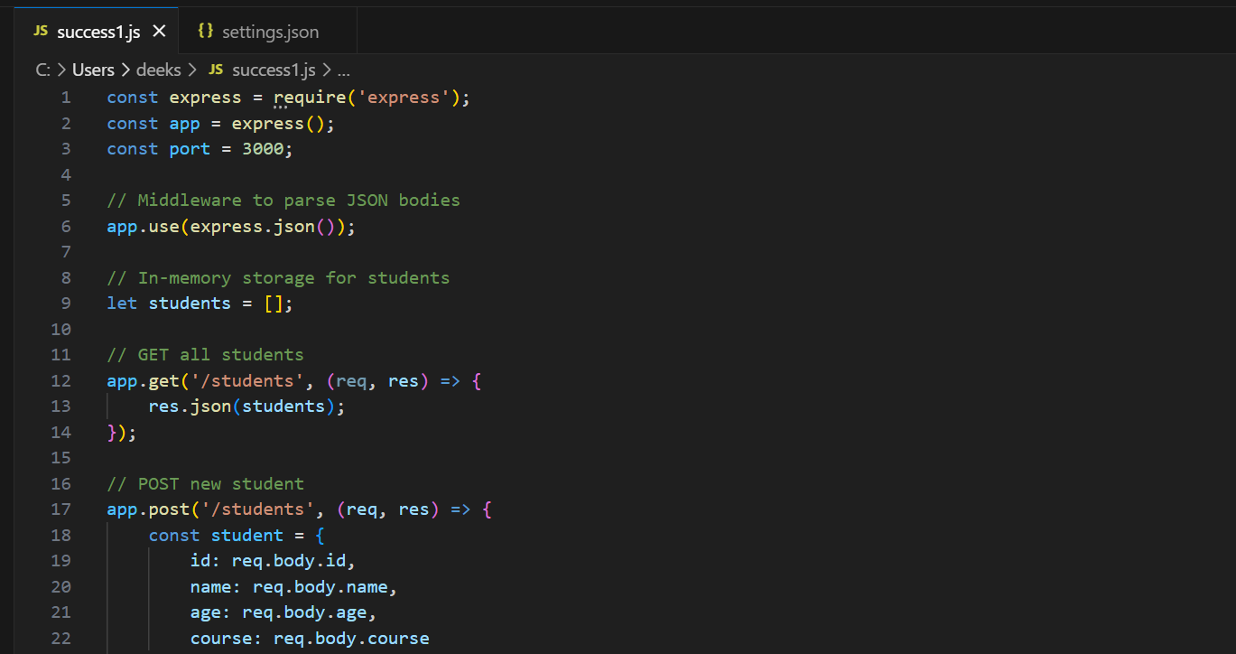
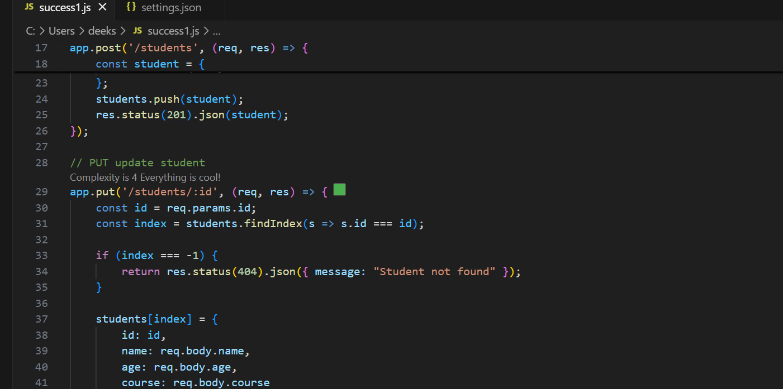
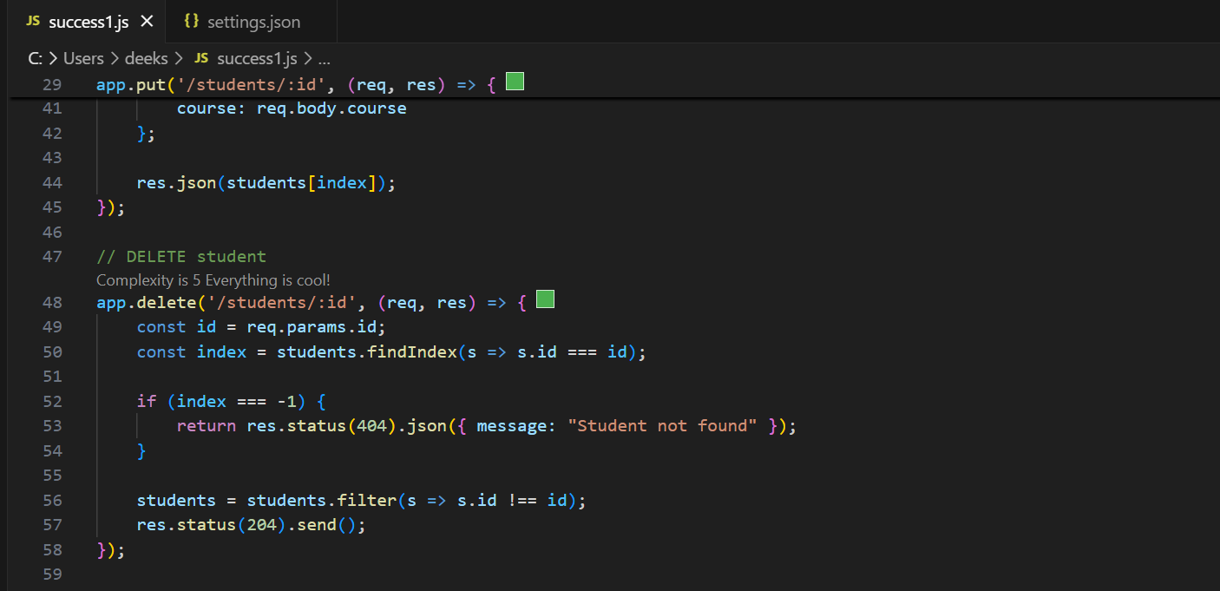
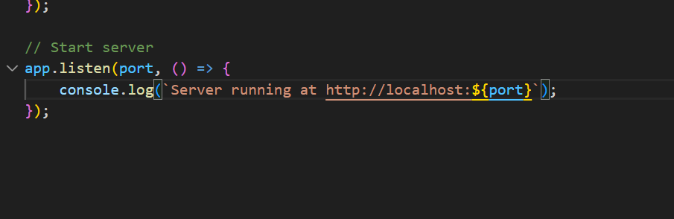
# OUTPUT:
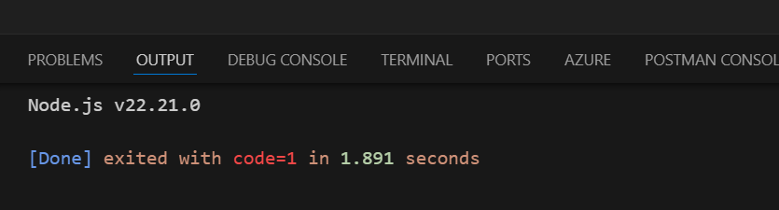
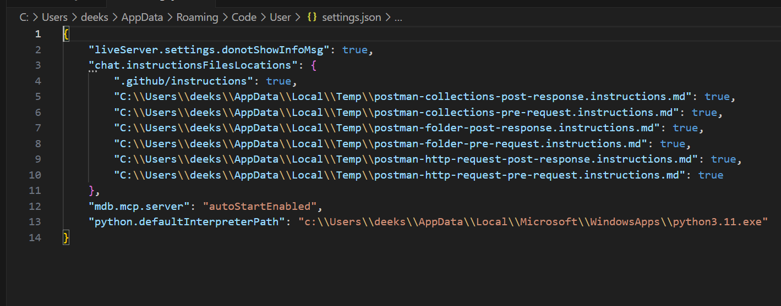
#TASK DESCRIPTION-3:
API with Query Parameters
Task: Ask AI to generate a REST API endpoint
#PROMPT:
Generate a complete and executable Flask REST API with one endpoint /search that accepts query parameters like name and age. The endpoint should return a JSON response containing the received parameters. Include all necessary Flask setup code.

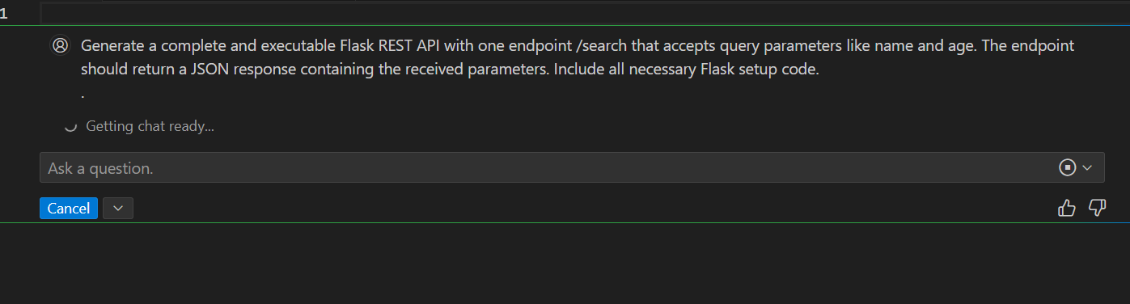

#CODE:
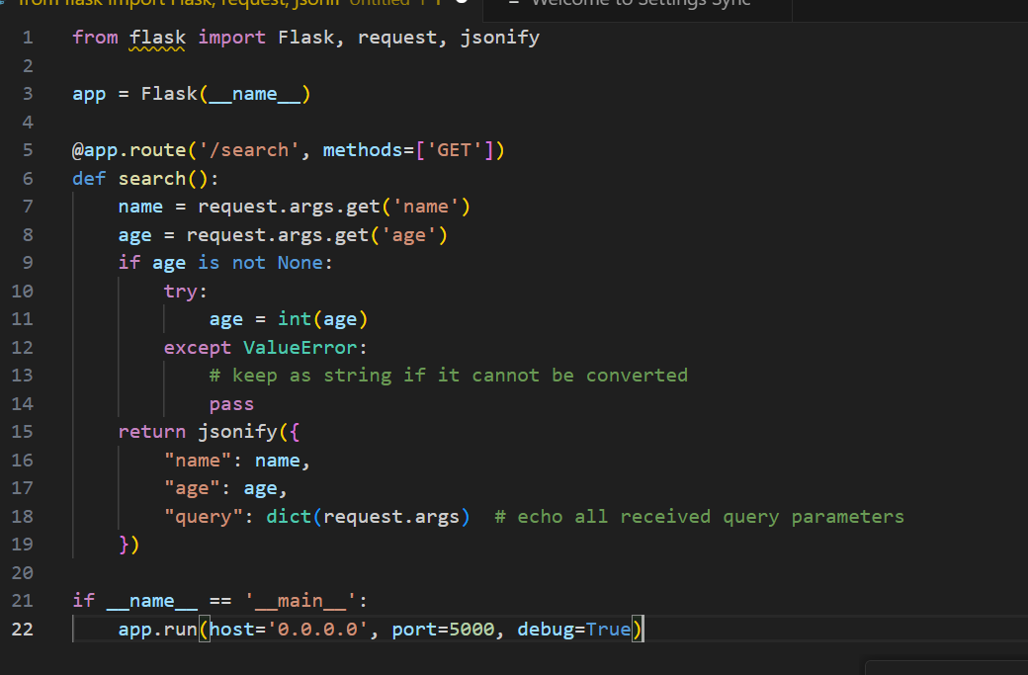
#OUTPUT:
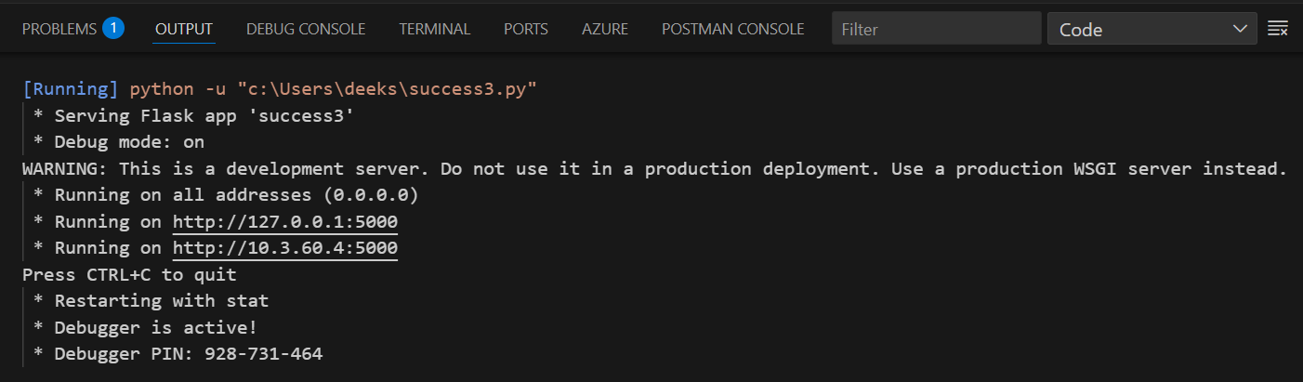

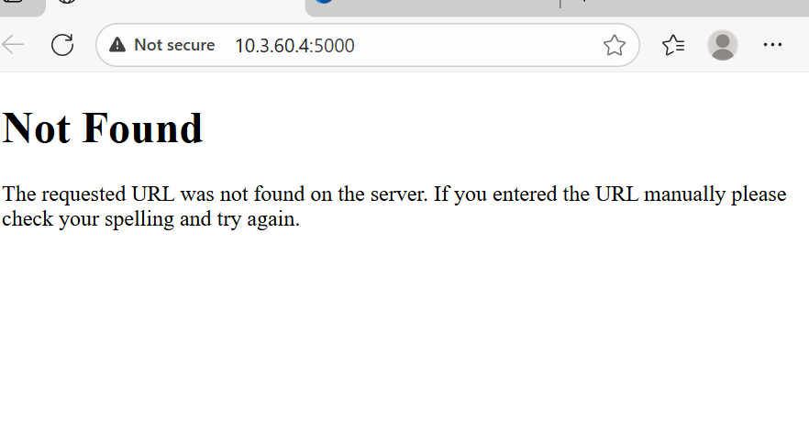
#TASK DESCRIPTION-4:
Integration & Testing
Task: Ask AI to write test scripts using Python requests module to call
APIs created above.

#PROMPT:
Generate Python test scripts using the requests module to test the Flask API endpoints created earlier (GET, POST, PUT, DELETE). Each request should print the API response clearly. Include complete and executable Python code.
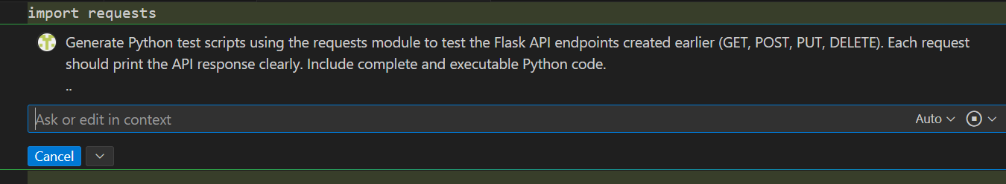
#CODE:
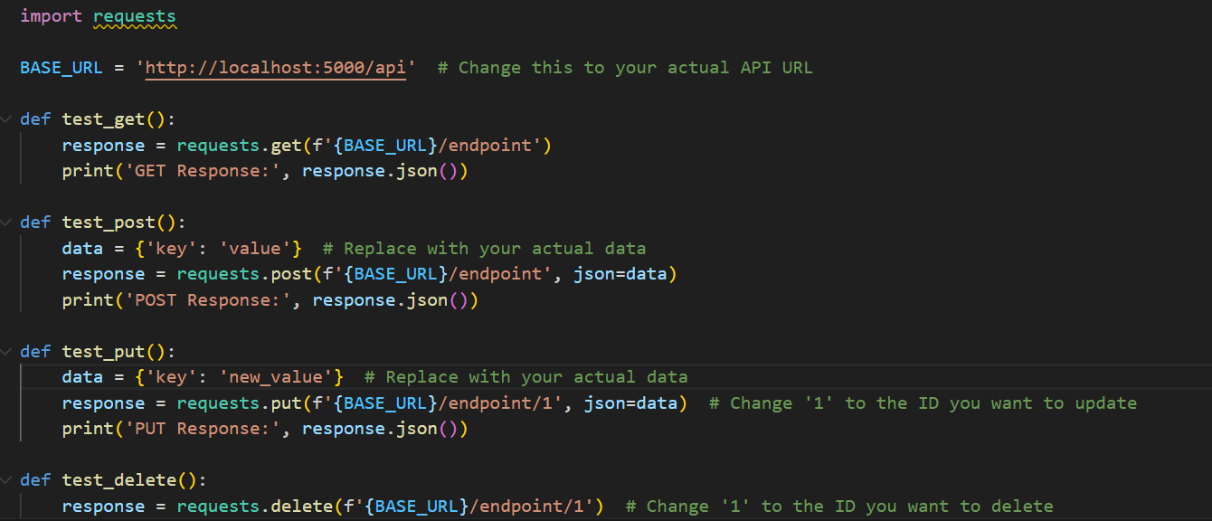
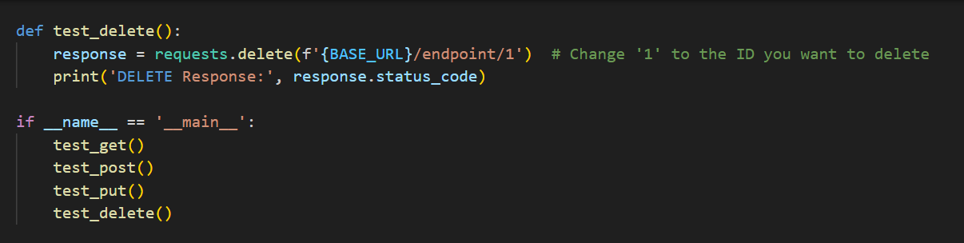
#OUTPUT:

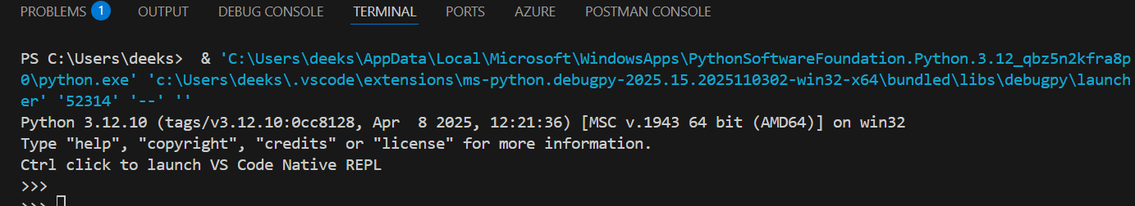

------- Thank You-------

